East Providence High School
Class of 1987 -30th Reunion
__________________________________________________________________________________________________________________

Saturday, September 9, 2017 ~ 5-10pm
Chelo’s on the Waterfront – 1 Masthead Drive, Warwick RI
Buffet Dinner and Live Entertainment
$50 per person
____________________________________________

Name:_________________________________________Maiden______________
Address:___________________________________________________________
Email:_____________________________________________________________
Number attending:__________ Payment amount enclosed:___________________
Checks can be made out to: EPHS Class of 1987
Please complete form and mail in payment by August 1st to: 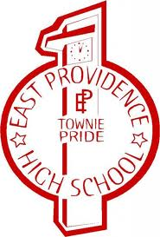
EPHS Class of 1987 ~10 Tanglewood Drive ~ Riverside, RI 02915

